|  |
| --- |
| Project proposal  Volcanic Eruptions |
| **Presented by**  **Zacharias Girmay**  **Prakriti Rana**  **Amanda Gaston**  **Camilla Bahr** |



**Introduction:**

Global Warming: The world's volcanoes, both on land and undersea, generate about 200 million tons of carbon dioxide (CO2) annually, while our global automotive and industrial activities generate about 24 billion tons of CO2 emissions annually.

**Dataset:** Extracted data from [https://webservices.volcano.si.edu/geoservices/GVP-VOTW/](https://data.humdata.org/contribute) and utilized Jupyter notebook to clean data in order to find the coordinates of the volcanic eruptions.

**Dashboard:** Features interactive and visualization pages with drop-down options.

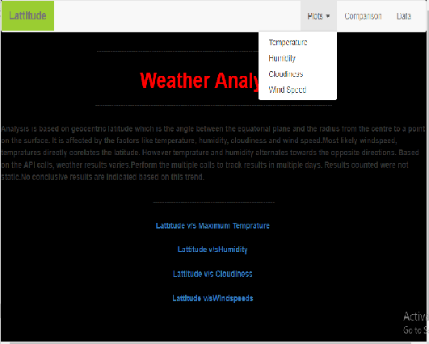

**Interactive:** Displays interactive eruptions featuring d3.



Visualization**:** Depicts the locations of the eruptions, using Leaflet.

